Threat and Vulnerabilities

Vulnerability = Weakness

👉 A **vulnerability** is:
* A weakness or flaw in a system
* Something that could be exploited
Vulnerability
(A vulnerability is) a weakness in an information system, system security procedures, internal controls, or implementation that could be exploited or triggered by a threat source.
NISTIR 8323 under Vulnerability from NIST SP 800-30 Rev. 1. (NIST, 2022)
🧠 Internal Control (Simple Meaning)
Rules, security measures, and processes used inside an organisation to reduce risk and protect systems/data.
🔍 Examples of vulnerabilities

* Weak password
* No firewall
* Old/unpatched software
* No backup system

---

## 📌 Important point

👉 Vulnerability is mainly:
* A **technical weakness**
* Related to system design or implementation
---

Threat = Potential danger / attack

👉 A **threat** is:
* Something that can exploit the vulnerability
* Something that may cause harm
Threat
Any circumstance or event with the potential to adversely impact organizational operations (including mission, functions, image, or reputation), organizational assets, or individuals through an information system via unauthorized access, destruction, disclosure, modification of information, and/or denial of service.
Also, the potential for a threat-source to successfully exploit a particular information system vulnerability.
FIPS 200 under THREAT from CNSSI 4009 - Adapted NIST SP 1800-15B under Threat from FIPS 200 (NIST, 2022)

## 🔍 Examples of threats

* Hackers
* Malware
* Insider attacks
* Fire
* Flood
* Aircraft crash (their example)
---

# 🔗 3. Relationship between Threat & Vulnerability

👉 A threat needs a vulnerability to cause damage.

---

## 🧩 Simple example

* Vulnerability = weak password
* Threat = hacker

👉 Hacker exploits weak password → system compromised

---

# ✈️ 4. Their aircraft example (simple meaning)

👉 Data centre vulnerability:

* An aircraft could crash into it

BUT:

👉 Threat assessment says:

* Probability is LOW

So organisation:

* Accepts/transfers/monitors the risk
* Handles it in disaster recovery planning

---

# 📊 5. Threat is NOT technical — it is risk-based

This is VERY IMPORTANT.

👉 Vulnerability = technical weakness
👉 Threat = likelihood/probability of harm

---

# 🛡️ 6. Risk Management Responses

Threats are managed by:

| Response | Meaning |
| -------- | ---------------------------------- |
| Accept | live with the risk |
| Avoid | remove the activity |
| Control | reduce risk with security measures |
| Transfer | insurance / outsource |
| Monitor | keep watching the risk |

---

7. Threat Modelling (VERY IMPORTANT)

👉 Threat modelling means:

👉 *Studying how attackers might attack a system and how defenders can protect it.*
Threat Modelling
A form of risk assessment that models aspects of the attack and defense sides of a logical entity, such as a piece of data, an application, a host, a system, or an environment.
NIST SP 800-53 Rev. 5 from Draft NIST SP 800-154 (NIST, 2022)

* What can go wrong?
* Who might attack?
* Which vulnerabilities exist?
* How can we defend against them?

---

Simple Example of Threat Modelling

### Web application

| Element | Example |
| ------------- | ---------------------- |
| Asset | Customer data |
| Vulnerability | SQL Injection |
| Threat | Hacker |
| Defence | Input validation / WAF |

# 🎯 SUPER SIMPLE MEMORY TRICK

👉 **Vulnerability = Weakness**
👉 **Threat = Danger/Attacker**
👉 **Risk = Threat exploiting vulnerability**

# 🔥 GOLDEN EXAM SENTENCE

👉
*A vulnerability is a weakness in a system, while a threat is a potential event or actor capable of exploiting that weakness to cause harm.*
# 🧠 One-line understanding
**No vulnerability = threat cannot easily succeed**
# ⚡ Cybersecurity formula to remember
👉
Risk = Threat \times Vulnerability \times Impact

This is the core idea behind risk assessment.
This formula is a simple way to understand how cybersecurity risk is created 👇
$$Risk=Threat×Vulnerability×Impact$$
🧠 Simple Meaning
👉 Risk becomes bigger when:
- The threat is strong or likely
- The vulnerability is serious
- The impact (damage) is high
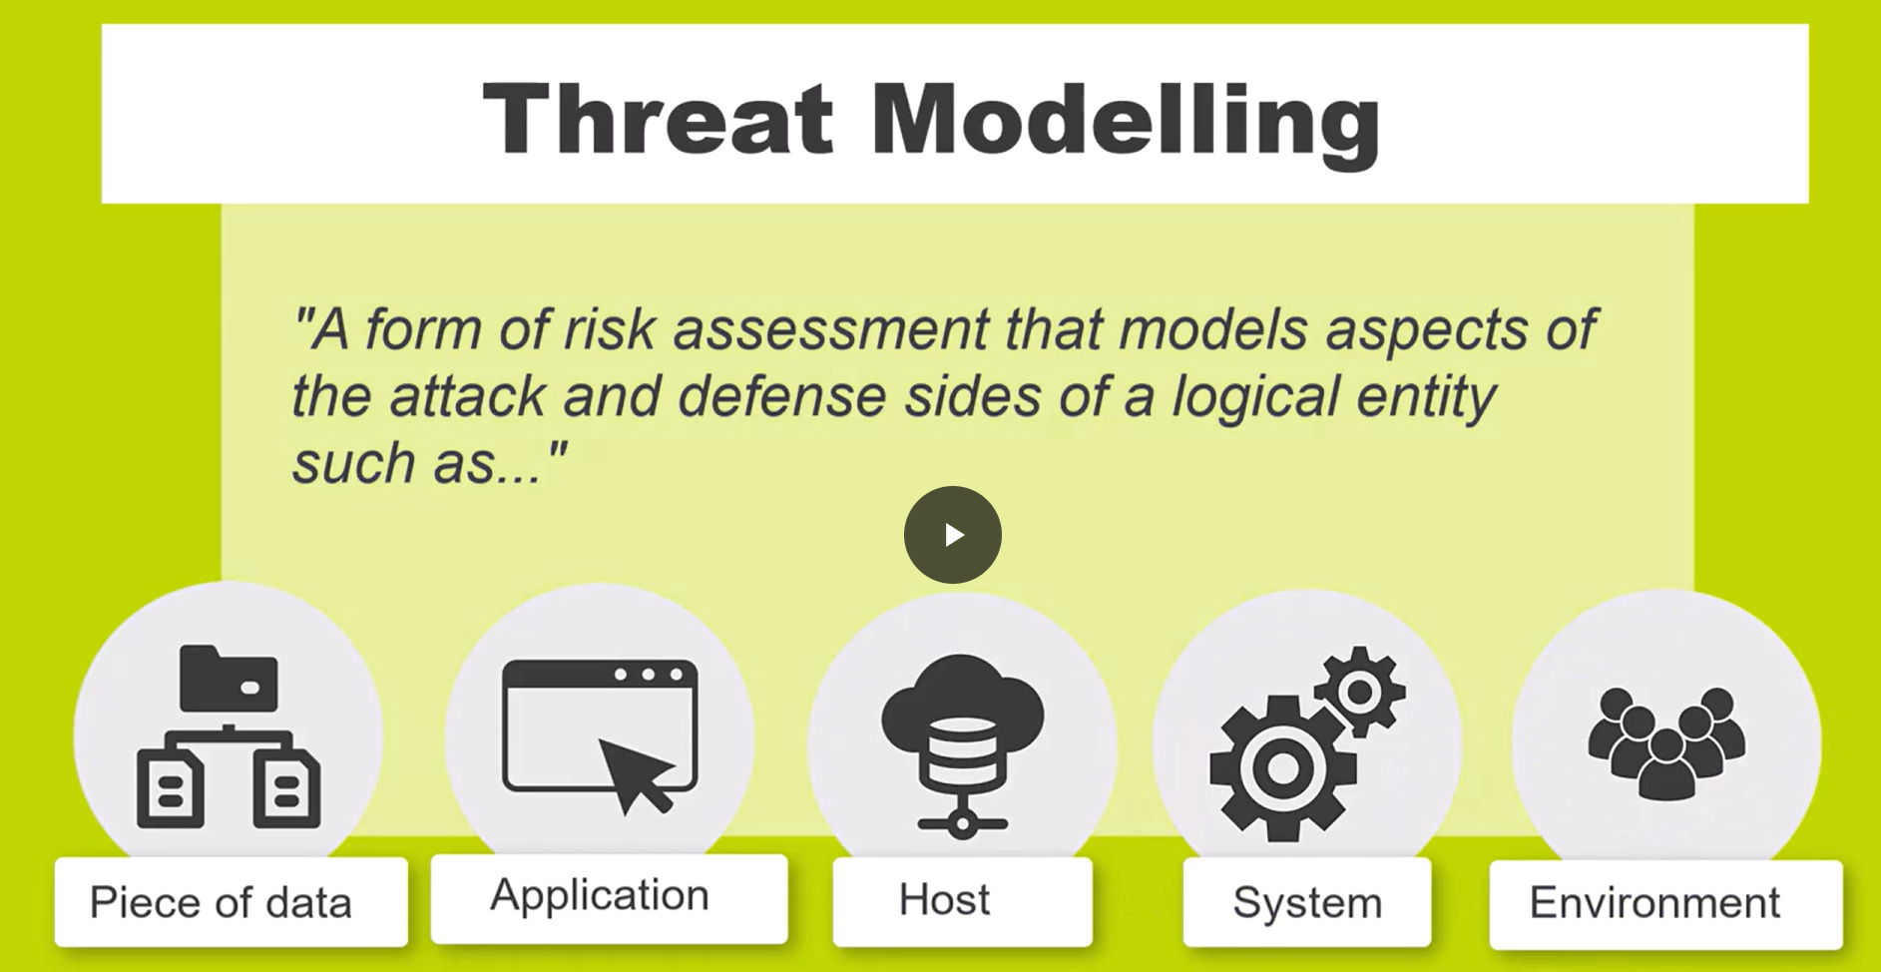
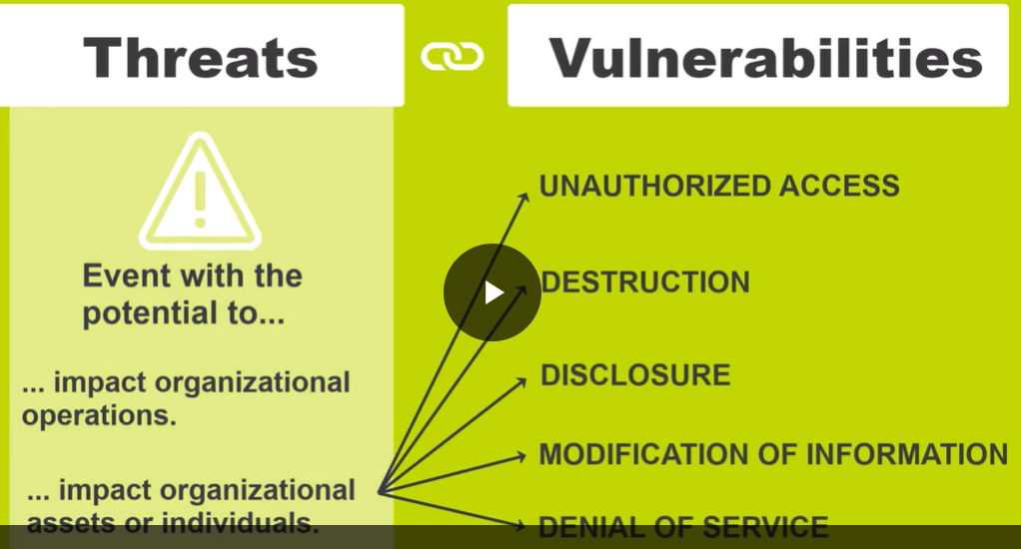

Threat and Vulnerabilities video transcript
Page 1 of 2
University of Essex Online Page 1 of 2
Threats and Vulnerabilities
It is worth starting by reviewing the relationship between threats and vulnerabilities. As the definition
from the Computer Security Response Centre (NIST CSRC) says:
"(A vulnerability is) a weakness in an information system, system security procedures, internal controls,
or implementation that could be exploited or triggered by a threat source."
NISTIR 8323 under Vulnerability from NIST SP 800-30 Rev. 1. (NIST, 2022)
Based on this definition - a vulnerability is a technical issue based on the design and/or implementation
of a system, or part thereof. Some sources expand the definition to deal with vulnerabilities as an
aspect of omissions or deviations from stated standards or internal regulations.
To take an extreme example - a vulnerability of most (all?) data centres is the possibility of an
aeroplane crashing into it and wiping it out - seriously affecting its availability. How this (and all other
vulnerabilities) are managed are based on a threat assessment.
A threat is defined as:
"Any circumstance or event with the potential to adversely impact organizational operations (including
mission, functions, image, or reputation), organizational assets, or individuals through an information
system via unauthorized access, destruction, disclosure, modification of information, and/or denial of
service. Also, the potential for a threat-source to successfully exploit a particular information system
vulnerability."
FIPS 200 under THREAT from CNSSI 4009 - Adapted NIST SP 1800-15B under Threat from FIPS
200 (NIST, 2022)
This definition clearly shows that a threat is a probability or risk-based measure, not a technical one. As
such it is measured by a risk management process - i.e. it is evaluated and then classified as accept,
avoid, control, transfer or monitor.
Page 2 of 2
University of Essex Online Page 2 of 2
Going back to the (extreme) example, although an aircraft accident is a vulnerability, as a threat it will
usually be evaluated as low risk and is usually managed as part of the BC/DR process (i.e. it is
transferred and monitored as part of the BC/DR strategy)
From these definitions we can supply a definition for Threat Modelling, which is defined as:
"A form of risk assessment that models aspects of the attack and defense sides of a logical entity, such
as a piece of data, an application, a host, a system, or an environment".
NIST SP 800-53 Rev. 5 from Draft NIST SP 800-154 (NIST, 2022)

Threat Modelling Manifesto
Threat modelling means:
- identifying possible cyber threats,
- understanding vulnerabilities,
- analysing risks,
- and designing protections before attacks happen.
The manifesto encourages:
- proactive thinking,
- honest analysis,
- fixing weaknesses early.

In an approach akin (MOSHABEH) to the Agile Manifesto (Highsmith et al, 2001) the authors quote their values as:
1. A culture of finding and fixing design issues over checkbox compliance
Security should focus on actually solving problems, not just ticking boxes to satisfy policies or audits.
2. People and collaboration over processes, methodologies, and tools
Tools are useful, but security mainly depends on:
- communication,
- teamwork,
- shared understanding.
3. A journey of understanding over a security or privacy snapshot
Threat modelling should therefore be:
- ongoing,
- reviewed regularly,
- updated throughout the system lifecycle.
4. Doing threat modelling over talking about it
The manifesto encourages organisations to actually perform threat modelling activities instead of only discussing security theoretically.
5. Continuous refinement (pallayesh) over a single delivery
Threat modelling should improve continuously during development and operation.
Not:
- “We did one security review at the beginning.”
But:
- repeated reviews,
- updates after changes,
- learning from incidents.
Example
After adding cloud services or AI components, the threat model should be updated.

In addition, the principles state:
Use a Systematic Approach
_
This principle recommends the use of existing methodologies and approaches to establish threats.
Informed Creativity
–
This principle recommends the use of various approaches – including intuitive ones, such as those described by Shostack and Associates (2021).

Varied Viewpoints
–
This principle recommends that you welcome all views – not just risk or threat management experts but also SMEs of the systems in question, and even just regular users.
Useful Toolkit(s)
–
This principle recommends that you become familiar with the various toolkits and methodologies available, so that you have a choice of approaches for different situations.
Theory into Practice
–
Finally, this principle recommends that you study journals and whitepapers to learn from others how best to analyse and model threats.
Finally, the manifesto presents a number of Anti-patterns including:
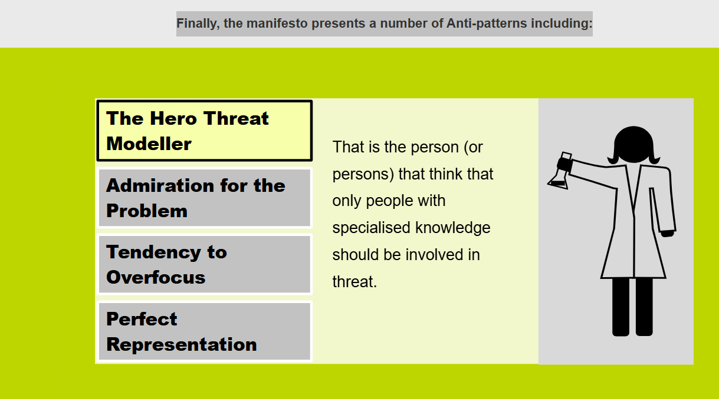
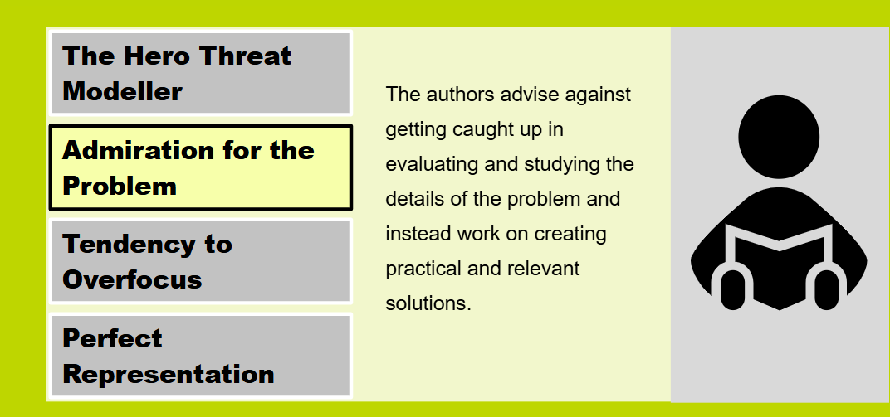
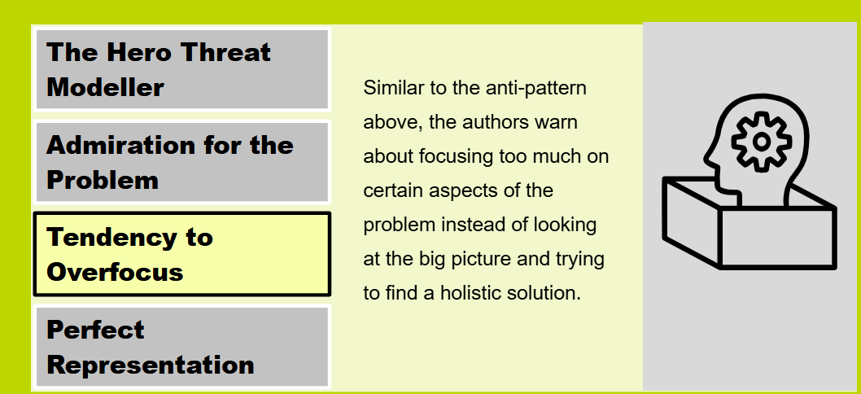
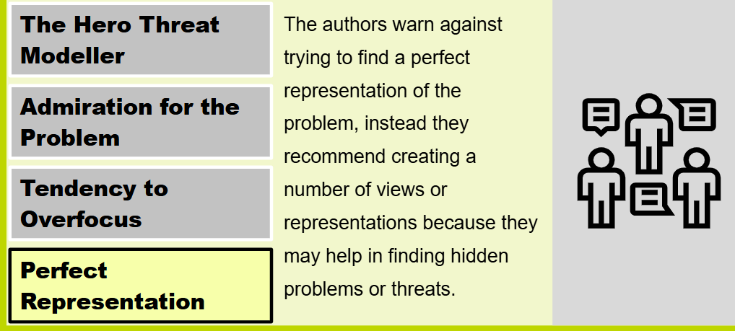

An Introduction to Threat Management Models
Shevchenko et al (2018) produced a comprehensive paper that summarised the most common threat management and modelling methods currently in use.
Threat modelling should be performed early in the development cycle. This means that potential issues can be caught early and remedied, preventing a much costlier fix down the line.
Shevchenko et al, 2018
Threat modelling should be performed early in the development cycle. This means that potential issues can be caught early and remedied, preventing a much costlier fix down the line.
Shevchenko et al, 2018
They also make the point that early application of the principles may allow architectural decisions to be made that can reduce both vulnerabilities and the threat attack surface.
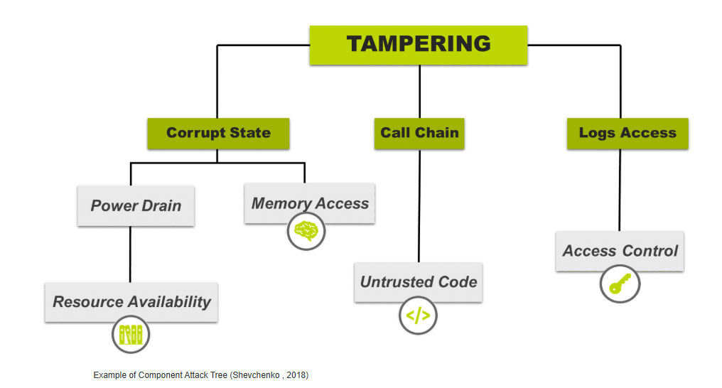
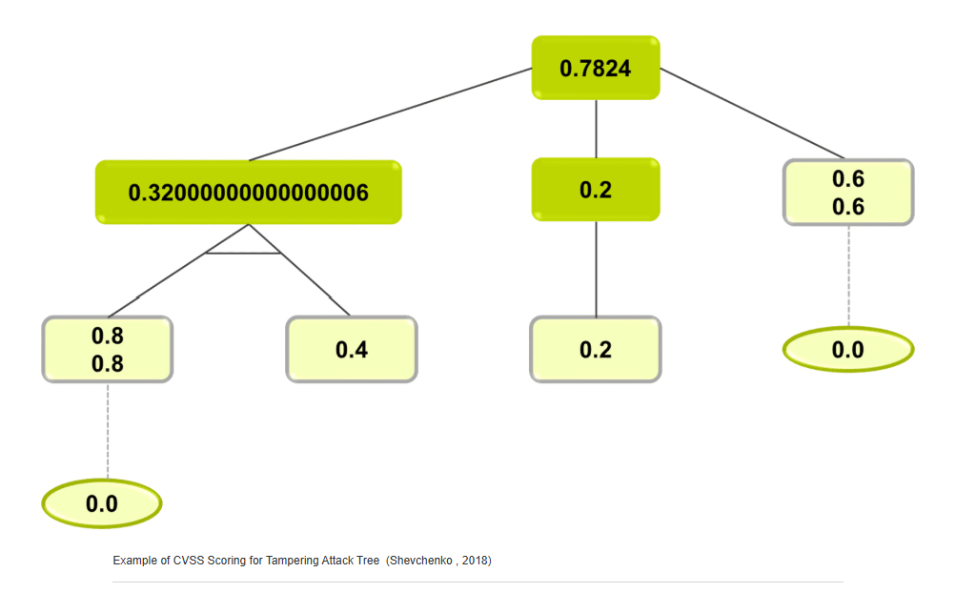
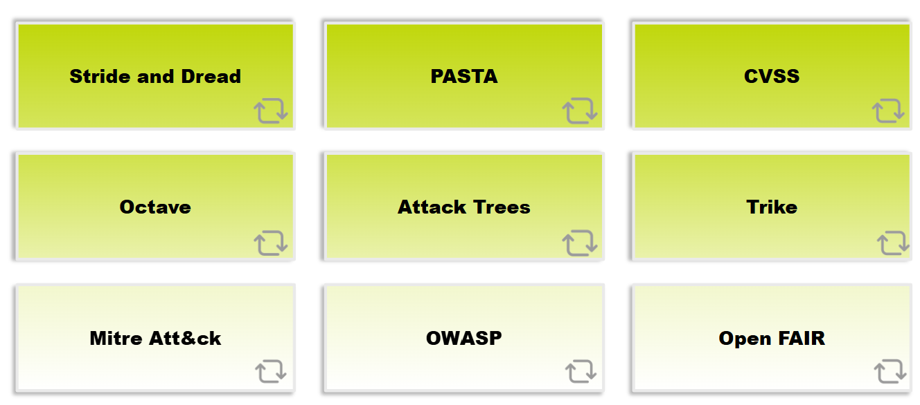
FThreat Modelling Quick Notes
What is Threat Modelling?
A structured process used to:
- identify threats,
- discover vulnerabilities,
- analyse risks,
- and design security controls.
Goal:
Reduce security risks before attackers exploit them.
Threat Modelling Manifesto Principles
- Fix real security problems over checkbox compliance
  - Focus on genuine protection, not just audits.
- People and collaboration over tools
  - Security works best when teams communicate.
- Continuous understanding over one-time review
  - Threats evolve constantly.
- Doing threat modelling over discussing it
  - Practical analysis is more valuable than theory alone.
- Continuous refinement over single delivery
  - Security must improve throughout the system lifecycle.

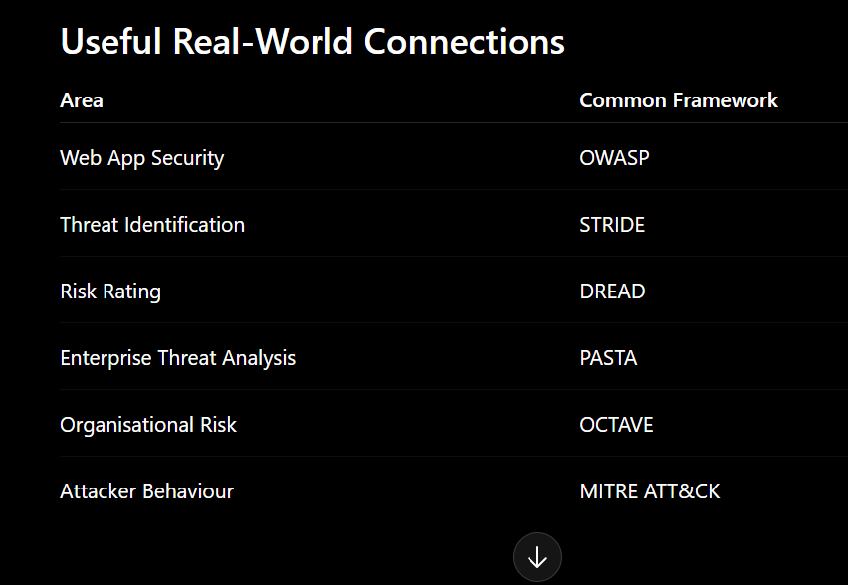

STRIDE
To support the threat modelling process Microsoft also created a threat classification known as Stride, and a Risk rating system known as Dread.
Stride classifies threats into six main categories:

Used to identify categories of threats.

Letter | Meaning
S | Spoofing: The attacker pretends to be someone or something else.
T | Tampering: Modifying the asset or an associated asset.
R | Repudiation: opposite of non-repudiation (the ability to deny the ownership of data or a message.)
I | Information Disclosure: Accessing unauthorised data
D | Denial of Service: non-availability.
E | Elevation of Privilege: Raising their authorisation/access to the asset.
DREAD
The Dread risk rating defines the risk associated with any given threat, where each element is rated numerically, often out of ten. Dread is an acronym for:
Used to rank risk severity.
Letter | Meaning
D | Damage: Total amount of harm an attack cause
R | Reproducibility: How easy is it to reproduce the threat/attack
E | Exploitability: How easy is it to exploit the threat – does it need special tools/skills
A | Affected Users
D | Discoverability: Is this threat secret, or in the public domain?
PASTA
Process for Attack Simulation and Threat Analysis.
Focus:
- attacker behaviour,
- business impact,
- attack simulation.

OCTAVE
Operationally Critical Threat, Asset, and Vulnerability Evaluation.
Focus:
- organisational risk,
- critical assets,
- operational security.

Attack Trees
Visual diagrams showing possible attack paths.
Example:
Gain Admin Access
├── Password Attack
├── Malware
└── Phishing

MITRE ATT&CK
Knowledge base of real attacker tactics and techniques.
Used in:
- SOC,
- threat intelligence,
- incident response.
Examples:
- Credential Access
- Persistence
- Lateral Movement

OWASP
Web application security framework.
Known for:
- OWASP Top 10,
- secure coding guidance.
Common vulnerabilities:
- SQL Injection
- XSS
- Broken Authentication

The Common Vulnerability Scoring System (CVSS)
The Common Vulnerability Scoring System (CVSS) is often referenced as a key metric for cybersecurity. According to NIST:
(CVSS) is an open framework for communicating the characteristics and severity of software vulnerabilities. CVSS consists of three metric groups:
- Base
- Temporal
- Environmental
A CVSS score is also represented as a vector string, a compressed textual representation of the values used to derive the score. Two common uses of CVSS are calculating the severity of vulnerabilities discovered on one's systems and as a factor in prioritization of vulnerability remediation activities. The National Vulnerability Database (NVD) provides CVSS scores for almost all known vulnerabilities.
NIST 2022 NVD Metrics
Exploitability = 20 x AccessVector x AccessComplexity x Authentication
Impact = 10.41 x (1 – (1 – Conflmpact) x (1 – IntegImpact) x (1 – AvailImpact))
𝑓(Impact) = { 0, if Impact = 0 ; 1.176, otherwise
BaseScore = roundTo1Decimal(((0.6 x Impact) + (0.4 x Exploitability) – 1.5) x 𝑓(Impact))
Basic metric calculation for CVSS v2 from Wikimedia.

There have been several versions of CVSS, v1.0, v2.0, v3.0, and v3.1. The older versions were deprecated due to feedback around perceived failings raised by vendors.
Spring et al (2021) produced a paper which summarised a number of the issues many found with the current CVSS ratings which can be summarised as:
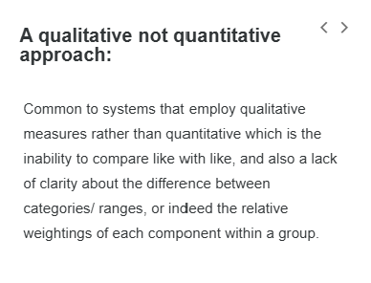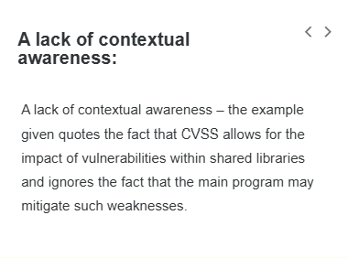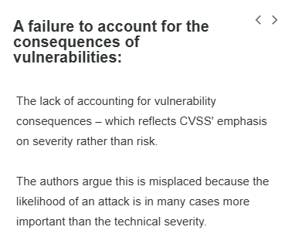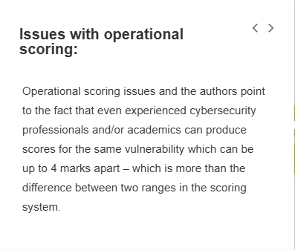
First: What is CVSS?
CVSS stands for:
Common Vulnerability Scoring System
It is a standard system used to score the severity of cybersecurity vulnerabilities.
Usually scores vulnerabilities from:
Score | Severity
0.1–3.9 | Low
4.0–6.9 | Medium
7.0–8.9 | High
9.0–10 | Critical
Example:
- A remote code execution vulnerability may score 9.8 Critical.
1. “A qualitative not quantitative approach”
Meaning
The criticism says CVSS is not truly mathematical or scientific enough.
Although CVSS gives numbers like:
7.5
9.8
5.4
those numbers are partly based on:
- human judgement,
- categories,
- subjective decisions.
So it is more qualitative (opinion/category-based)
than fully quantitative (purely measurable).

Simple Example
Two analysts may disagree whether:
- exploitability is “High”
or
- “Medium”.
This changes the final score.

Main Problem
CVSS sometimes cannot compare risks accurately because:
- different factors are weighted strangely,
- categories overlap,
- scoring can be inconsistent.

2. “Lack of contextual awareness”
Meaning
CVSS often ignores the specific environment where the vulnerability exists.
But context matters hugely in cybersecurity.

Example
A vulnerability in a shared software library may look dangerous.
BUT:
- the main application may already block exploitation,
- firewall rules may reduce risk,
- segmentation may isolate the system.
CVSS may still give it a very high score.
3. “Failure to account for consequences”
Meaning
CVSS focuses heavily on technical severity rather than real business risk.
But in practice:
likelihood and impact to the organisation matter more.

Important Difference
Severity | Risk
Technical danger level | Real-world business impact + probability

Example
A vulnerability may technically score:
9.8 Critical
BUT:
- attacker access is nearly impossible,
- system is isolated,
- no sensitive data exists.
Actual risk may therefore be low.
Meanwhile:
- a Medium vulnerability exposed to the internet
may be more dangerous operationally.

4. “Issues with operational scoring”
Meaning
Different experts may score the same vulnerability differently.
This creates inconsistency.

Example
One analyst:
CVSS = 9.1
Another:
CVSS = 5.4
That is a huge difference.

Why?```````````````````````````````````````````````````````````````````
Because humans interpret:
- exploitability,
- impact,
- privileges,
- complexity
differently.

Main Criticism
The scoring system may appear objective,
but human judgement still affects results significantly.

5. “Effect of weightings on CIA”
This refers to the:
CIA Triad
Letter | Meaning
C | Confidentiality
I | Integrity
A | Availability

What the criticism says
CVSS often treats:
- confidentiality,
- integrity,
- availability
as equally important.
But in reality they are NOT equally important for every organisation.

Example
Bank
Most important:
- Confidentiality,
- Integrity.
Hospital
Availability may be most critical.
Military system
Integrity may be most important.

Problem
CVSS uses general weighting,
but real organisations have different priorities.

Final Overall Criticism of CVSS
The images conclude that CVSS has issues with:
- subjectivity,
- lack of business context,
- inconsistent scoring,
- limited operational realism,
- oversimplified weighting,
- focus on severity rather than actual risk.

Important Academic Understanding
CVSS is still VERY useful.
It helps:
- standardise vulnerability scoring,
- prioritise patching,
- communicate severity.
BUT:
organisations should not rely only on CVSS scores.
Good cybersecurity also considers:
- business impact,
- threat intelligence,
- exploit likelihood,
- environment,
- asset value,
- operational context.

Simple Exam/Assignment Sentence
CVSS provides a standardised method for vulnerability severity scoring; however, critics argue that it lacks contextual awareness, contains subjective elements, and may not accurately reflect real-world organisational risk.
STRIDE & DREAD
As defined previously, threat assessment is closely linked to the more generic risk assessment process, except that it requires a more technically based assessment. There are various tools and models available perform a threat assessment but a widely known and used set of tools come from Microsoft.
The Microsoft Threat Modelling process is shown in the accompanying accordion below. It is an iterative, six step process that requires the analyst to:
1. Identify Assets
–
Identify the assets under threat (such as a web site, web application, data centre, database, etc.).
2. Create an Architecture Overview
–
Create an architecture overview that describes data and process flows, external systems and subsystems and boundaries between different domains and security levels.

3. Decompose the Application
–
Decompose the application, identifying key components so that known vulnerabilities can be traced.
4. Identify the Threats
–
Identify the threats that may affect the application (using a framework such as Stride, explained later).
5. Document the Threats
–
Document the threats so that risk assessment is easier;.
6. Rate the Threats
–
Rate the threats using a framework such as Dread (explained later)

STRIDE
To support the threat modelling process Microsoft also created a threat classification known as Stride, and a Risk rating system known as Dread.
Stride classifies threats into six main categories:
Spoofing: pretending to be someone or something else.
Tampering: attacker tries to modify the asset.
Repudiation: ability to deny the ownership of data or a message.
Information Disclosure: the attacker gets access to assets that they are not authorised to.
Denial of service: service unavailability

DREAD
The Dread risk rating defines the risk associated with any given threat, where each element is rated numerically, often out of ten. Dread is an acronym for:

D | Damage: Total amount of harm an attack cause
R | Reproducibility: How easy is it to reproduce the threat/attack
E | Exploitability: How easy is it to exploit the threat – does it need special tools/skills
A | Affected Users: how many people have been affected.
D | Discoverability: Is this threat secret, or in the public domain?

The OCTAVE Process
According to ENISA (Lambrinoudakis et al, 2022), "The OCTAVE Method (Operationally Critical Threat, Asset, and Vulnerability Evaluation) was developed in 1999 at the (CMU) Software Engineering Institute. Since then it has been updated and diverse versions have been published."
The baseline OCTAVE methodology consists of 3 phases, according to Shevchenko et al (2018), which can be seen in the Figure and are described below:
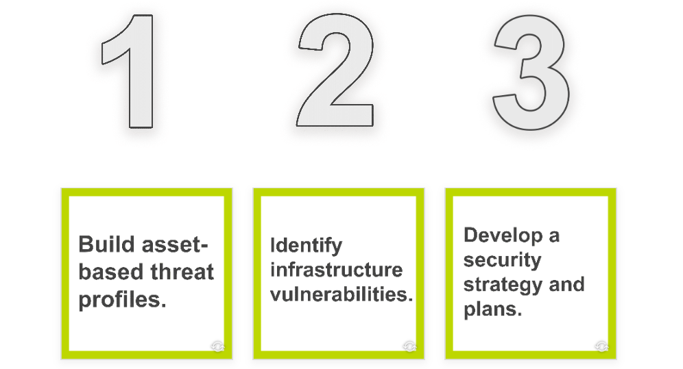
  - This is organisational evaluation
  - Evaluation of the information infrastructure
  - This is identification of risks to the orgnization’s critical assets and decision making
In simple terms, the 3 phases usually mean:
- Identify critical assets
  - determine what systems/data are most important.
- Identify threats and vulnerabilities
  - analyse what could attack or damage those assets.
- Develop risk mitigation strategies
  - decide how to reduce or manage the risks.

The 'diverse versions' discussed by ENISA include:
- bullet
OCTAVE-S
- bullet
OCTAVE ALLEGRO
- bullet
OCTAVE FORTE
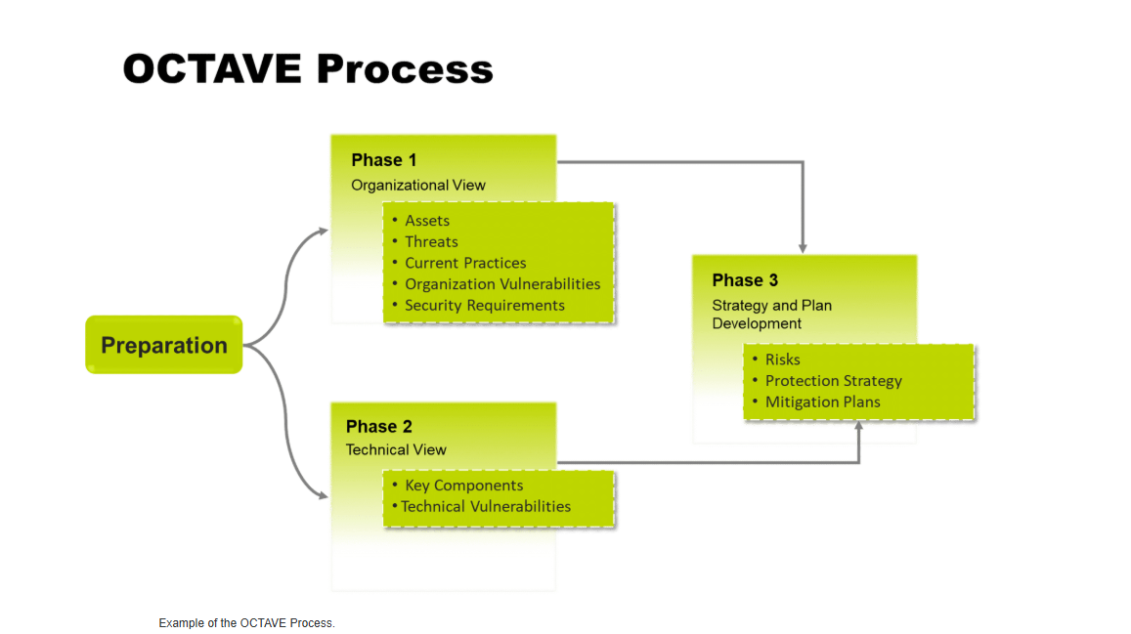
The 'diverse versions' discussed by ENISA include:
- bullet
OCTAVE-S
- bullet
OCTAVE ALLEGRO
- bullet
OCTAVE FORTE
OCTAVE-S is designed to be used by smaller organisations. It is a streamlined version designed to be implemented by teams of 3 to 5 people. According to Lambrinoudakis et al (2022), OCTAVE-S follows 3 phases:

Phase 1 aims at building asset-based threat profiles, by defining criteria for evaluating impacts, identifying important organisational assets and defining security requirements.
In this phase, the team select three to five critical assets to analyse in depth, based on their relative importance to the organisation, and defines a threat profile for each critical asset.
In Phase 2 infrastructure vulnerabilities are identified, by analysing how people use the computing infrastructure to access critical assets and by identifying who is responsible for configuring and maintaining critical components.
During Phase 3, the team identify risks to the organisation’s critical assets and creates a protection strategy for the organisation and mitigation plans to address the risks to the critical assets. The OCTAVE-S provides worksheets to support this phase.
OCTAVE ALLEGRO
OCTAVE ALLEGRO broadly follows the standard OCTAVE methodology, but focuses on risk while trying to minimise the requirement for risk expertise in the implementers. It focuses on information assets and studies the risks and threats to those items (Lambrinoudakis et al, 2022).
According to the authors it is organised into 4 phases consisting of 8 steps in total – as shown below:
Phase 1
–
In phase 1, the organisation develops criteria for risk measurement that are consistent with organisational drivers.
Phase 2
–
In phase 2, information assets that are determined to be critical are profiled, so that clear boundaries for assets are established, including their locations (where the asset is stored, transported or processed), and security requirements are identified.
Phase 3
–
In phase 3, threats to the information assets are identified in the context of the locations where each asset is stored, transported or processed.
Phase 4
–
In the final phase, risks to information assets are identified and analysed, and the development of approaches to mitigation commences.
OCTAVE FORTE

The final (and latest) version is OCTAVE FORTE (for the enterprise). It was developed by Tucker in 2020 (Tucker, 2020). It leverages enterprise risk management (ERM) principles to identify security risks and help businesses formulate strategic objectives.
Lambrinoudakis et al (2022) provides a list of the 10 step process:
- Stablish Risk governess and appetite.
- Scope critical services and assets.
- Identity resilience requirements of assets.
- Measure current capabilities.
- Identify Risks, Threats and vulnerabilities to assets.
- Analys risks against capabilities.
- Plan for response.
- Implement the Response Plans.
- Monitor and measure for effectiveness.
- Review, update and Repeat

Attack Trees
An attack tree in information systems is an approach for modelling security vulnerabilities. A tree structure is built to analyse different security threats using different paths to achieve the attack goal, as well as enumerating the threat and the malicious users' methods for achieving their goal. Elementary attacks are placed at the leaf level, and primary attacks are placed at the root.
The non-leaf part of the trees are the internal nodes representing a combined attack of the elementary nodes in the next higher level. These can be combined by either conjunctive aggregation (AND nodes) or disjunctive (OR nodes). (Mauw & Oostdijk, 2005).
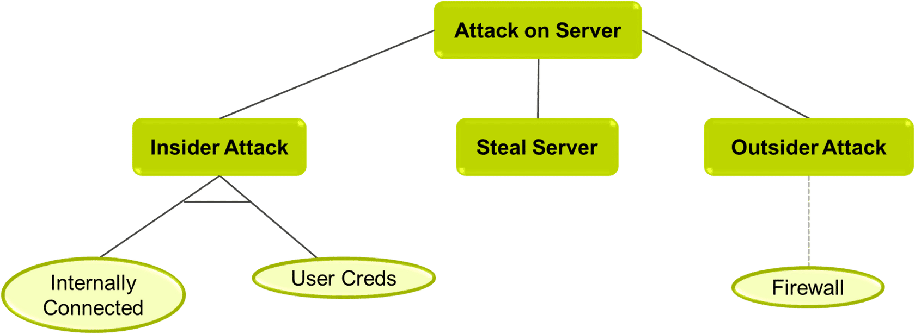
An ADTree for how to attack a server.
An attack tree is to visualise how attacks can happen, identify weak points, and improve protection
This text explains attack trees, a cybersecurity modeling method first introduced by Salter et al. in 1998 (though often credited to Schneier in 1999). It breaks down an attacker’s goal—like breaching a system—into smaller steps or alternatives, shown as a tree. The top (root) is the main objective, which splits into sub-goals:
- Conjunctive (AND) nodes mean multiple steps are needed together.
- Disjunctive (OR) nodes show different ways to reach the goal.
This continues until reaching "basic actions"—simple, atomic steps an attacker might take. Some tools let you add attributes like likelihood or risk to each node for deeper analysis. The text also notes attack trees are used in hybrid models, combining with other methods to assess complex threats.
Theory of attack trees and graph

stock-image.jpg
Salter et al. in 1998 coined the term attack trees for the first time (Salter et al, 1998) but is often only attributed and cited to Schneier (Schneier, 1999).

In the attack tree, the attacker’s goal is specified and depicted as the root of the tree.
The goal is then disjunctively or conjunctively redefined into sub-goals.
The refinement is repeatedly looped until the sub-goals represent basic actions.
Basic actions resemble atomic components for simple understanding and quantification.
Conjunctive refinements indicate different steps an attacker takes to achieve a goal.
While Disjunctive refinement indicates different alternatives of how a goal can be achieved (Qin & Lee, 2004).

In addition to decomposing attacks into more basic (atomic) elements, some tools allow the user to add attribute domains which allows the user to specify the probabilities of occurrence, success, risk, or similar measures of each element and analyse them with additional assumptions to cater for more complicated attributes. (Edge et al, 2006).

Attack trees have been used in various hybrid approaches – two of which are discussed below.

Attack - Defence Trees (ADTrees)

Kordy et al (2013) created the ADTool which can be used to construct models with the graphical ADTree language. The ADTree can model a defense mechanism for an attack called a defense term (ADTerm).

For model manipulation and management, the ADTool provides features such as expanding, folding, and zooming options to make the analysis of large models possible.

1.png
2.png
Parts of the tree are temporarily hidden permitting the users to focus on the displayed components, making it convenient for industrial meetings and presentations.

ADTool structures can be saved with the .adt file extension, enabling reuse and modification.

3.png
4.png
Models can also be viewed as raster graphics files (png, jpeg), vector graphics files (pdf), and LATEX files (tex).

ADTrees implement a bottom-up algorithm for the evaluation of attributes in ADTool (Kordy et al, 2013).

Another methodology called Quantitative Threat Modelling Methodology (QTMM) combines attack trees, STRIDE and CVSS – it is discussed in a paper by Luna et al (2012).

Another methodology called Quantitative Threat Modelling Methodology (QTMM) combines attack trees, STRIDE and CVSS – it is discussed in a paper by Luna et al (2012).
Lesson 9 of 14

Process for Attack Simulation and Threat Analysis (PASTA)
PASTA (Process for Attack Simulation and Threat Analysis) is a risk-centric threat modelling framework, proposed by Tony UcedaVélez in 2012 (Wolf et al, 2020).
The model consists of 7 stages as shown in the diagram below. Wolf et al (2020) use the model to perform a threat and risk analysis on an IOT system. Typically, PASTA recommends the use of other frameworks alongside, and integrated with its own methodology. The authors use attack trees and the STRIDE/DREAD methodology alongside PASTA. It also recommends the use of data flow diagrams (DFDs) to analyse the data flows within a system, which can also help identify possible vulnerabilities.
This image explains the PASTA threat modelling framework.
PASTA stands for Process for Attack Simulation and Threat Analysis. It is a cybersecurity method used to identify threats, vulnerabilities, and risks in a system.
The framework has 7 stages:
- Define Objectives
Understand the business goals, security needs, and possible business impact if attacks happen.
- Define Technical Scope
Identify the system boundaries, infrastructure, applications, and software involved.
- Application Decomposition
Break the system into smaller parts to understand data flows, users, assets, services, and trust boundaries.
Often uses Data Flow Diagrams (DFDs).
- Threat Analysis
Identify possible threats and attack scenarios using threat intelligence and security analysis.
- Vulnerability & Weakness Analysis
Find weaknesses, vulnerabilities, design flaws, and known security issues (such as CVEs/CWEs).
- Attack Modeling
Simulate how attackers may exploit vulnerabilities using attack trees and attack surface analysis.
- Risk & Impact Analysis
Evaluate the business impact, estimate risks, and decide mitigation strategies and countermeasures.
In simple terms, PASTA helps organisations:
- Understand what they must protect,
- Find weaknesses,
- Predict possible attacks,
- Measure risks,
- And improve security systematically.

ATT&CK
Bodeau et al (2018) explain that "Adversarial Tactics, Techniques, and Common Knowledge (ATT&CK, [MITRE 2015]) is a framework for describing the actions an adversary may take while operating within an enterprise network. It provides a detailed characterization of adversary behavior post-access, i.e., after initially gaining entry via a successful exploit. " It was originally focused on the Microsoft Windows environment; but has since been expanded to cover Mac OS, Linux and even mobile devices. It was initially designed as part of an internal Mitre project called FMX (Strom, 2018) but was released to the public when the team realised it could be a very valuable resource. The table provided shows the Att&ck database divided into its main (10) categories, the numbers in each category indicate the number of techniques described in each category. The matrices can be searched for vulnerabilities, threats, mitigations or even known groups that use cyber-espionage to attack industry. The Mitre group supply a number of blog posts and a downloadable e-book that explains how to use the database. The blog by Strom is a general introduction whereas Nichels focuses on threat intelligence.
A Web Shell is a malicious script uploaded to a web server that gives attackers remote control of the server through a browser.
DLL stands for Dynamic Link Library.
It is a Windows file (.dll) that contains code and functions used by programs. Multiple applications can share the same DLL file.
DLL Injection is an attack technique where a malicious DLL is inserted into a legitimate running program.
- This allows the attacker to:
  - run malicious code,
  - steal data,
  - control the application,
  - or gain higher privileges.
Simple example:
An attacker injects a malicious DLL into a trusted program like a browser or Windows process so the malware runs secretly.
A Web Shell is a malicious script uploaded to a web server that gives attackers remote control of the server through a browser.
A Shell generally means command-line access to a system. Attackers use shells to execute commands remotely.
In your sentence, both DLL Injection and Web Shell are examples of privilege escalation or attack techniques attackers use to gain more control over systems.
TACTIC | NUMBER | DESCRIPTION | DESCRIPTION
Persistence | 51 | Any access, action, or configuration change to a system that gives an adversary a persistent presence on that system.  Example: Bookit, Hypervisor. | How attackers stay inside a system for a long time even after reboot or logout.  Example: secretly installing malware that starts automatically.
Privilege Escalation | 27 | The result of actions that allow an adversary to obtain a higher level of permissions on a system or network.  Example: DLL Injection, Well Shell. | Gaining higher permissions or administrator access.  Example: exploiting a weakness to become “admin”.
Defense Evasion (حیله-طفره رفتن .) | 34 | Techniques an adversary may use to evade detection or avoid other defenses.  Example: Binary Padding, File Deletion. | Hiding malicious activity from antivirus or security systems.  Example: deleting logs or disguising malware.
Credential Access | 18 | Techniques resulting in access to or control over system, domain, or service credentials that are used within an enterprise environment.  Examples: Credential Dumping, Input Capture. | Stealing usernames, passwords, or login credentials.  Example: password dumping or keylogging.
Discovery | 17 | Techniques that allow the adversary to gain knowledge about the system and internal network.  Examples: Network Service Scanning, Query Registry. | Gathering information about the system or network.  Example: scanning devices, checking users or services.
Lateral Movement | 17 | Techniques that enable an adversary to access and control remote systems on a network and could, but do not necessarily, include execution of tools on remote systems.  Examples: Pass the Hash, Window Remote Management (WinRM) | Moving from one compromised computer to another inside a network.  Example: using stolen credentials to access other machines.
Execution | 25 | Techniques that result in execution of adversary-controlled code on a local or remote system.  Examples: PowerShell, Windows Management Instrumentation (WMI) | Running malicious code or commands on a system.  Example: using PowerShell scripts or malware execution.
Collection | 13 | Techniques used to identify and gather information, such as sensitive files, from a target network prior to exfiltration.  Examples: Audio Capture, Clipboard Data. | Gathering valuable data before stealing it.  Example: collecting files, clipboard data, or recordings.
Exfiltration | 9 | Techniques and attributes that result or aid in the adversary removing files and information from a target network.  Examples: Data Encrypted, Scheduled Transfer.
Command and Control | 19 | Represents how adversaries communicate with systems under their control within a target network.  Examples: Data Encoding, Uncommonly Used Port.

Open Web Application Security Project (OWASP)

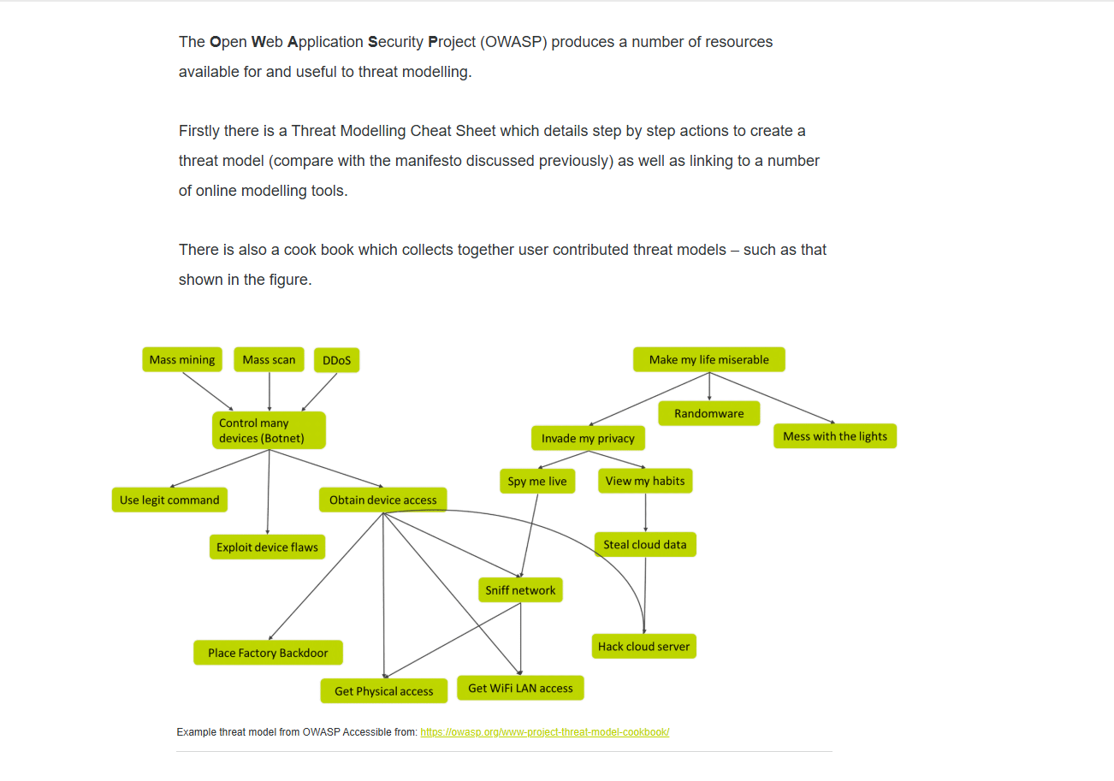
An indicative step of actions recommended by OWASP include:

Creating a DFD (Data flow Diagram) Template.
A diagram used to show:
- How data moves through a system,
- Where data is stored,
- Who sends and receives data.
Purpose: Helps identify security risks and trust boundaries.

Review the kill chain template (if appropriate). Available here.

A model showing the stages of a cyberattack from start to finish.
Typical stages:
- Reconnaissance (information gathering)
- Weaponization
- Delivery
- Exploitation
- Installation
- Command & Control
- Actions on Objectives
Purpose: Understand where attacks can be detected or stopped.

Create an Attack Tree.
A tree diagram showing:
- The attacker's goal at the top,
- Different paths to achieve that goal underneath.
Purpose: Helps think like an attacker and identify attack paths.

Component Enumeration Techniques
Use component enumeration techniques (see the cheat sheet for details).
The process of identifying all system components such as:
- Servers
- Databases
- Applications
- APIs
- Users
- Network devices
Purpose: Know what needs protection.

Attack library build out and mapping.
A collection of known attack methods and techniques.
Examples:
- SQL Injection
- Phishing
- Malware
- DDoS
Purpose: Map threats to specific system components.

Proposed Threat Library and Integration
A central database of threats integrated into the threat modelling process.
Purpose: Ensure common threats are consistently considered.
Create a weakness library; ensure it is maintained and integrated.

Weakness Library Management and Integration
A repository of known weaknesses and vulnerabilities.
Examples:
- Weak passwords
- Missing encryption
- Unpatched software
Purpose: Track and manage security weaknesses.

Lightweight Threat Modeling Steps
A simplified threat modelling approach for small projects.
Typical steps:
- Understand the system.
- Identify assets.
- Identify threats.
- Assess risks.
- Recommend mitigations.
Purpose: Fast and practical threat modelling.
What Should a Lightweight Process Produce?
The final output should include:
- System overview
- Key assets
- Main threats
- Risk assessment
- Recommended controls
Purpose: A simple security report.
. What Are the Simplest Steps We Can Follow to Arrive at That Deliverable?
- Draw a simple DFD.
- Identify important assets.
- List possible threats.
- Prioritise risks.
- Suggest mitigations.
The results of threat modelling:
✅ Better understanding of the system
✅ Identified threats and vulnerabilities
✅ Prioritised risks
✅ Security recommendations
✅ Improved security design
In one sentence:
Threat modelling helps you understand what you need to protect, what can go wrong, and how to reduce the risk.

